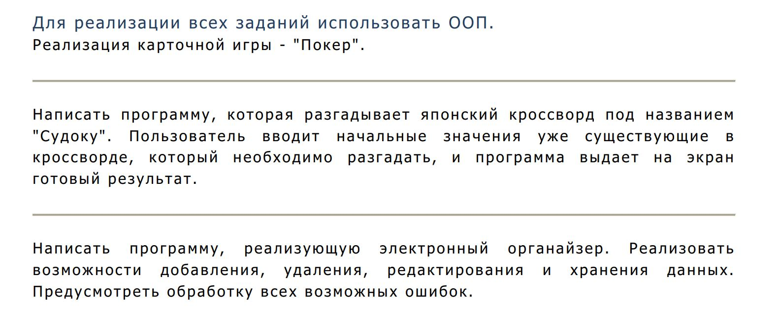
Гра 21

#define _CRT_SECURE_NO_WARNINGS
#include <iostream>
#include<Windows.h>
#include<string>
#include<list>
#include<vector>
#include<map>
#include"time.h"
#include<algorithm>
#include<iterator>
#include<io.h>
using namespace std;
class Card
{
string name;
char suit;//масть
int point;
public:
Card(string n, char s, int p):name(n),suit(s),point(p){}
void Show()
{
cout << this->name << this->suit;
}
int GetPoint()
{
return this->point;
}
string GetName()
{
return name;
}

};

class Game21
{
int bank_bankir;
vector<Card>koloda;
vector<Card>koloda_player;
vector<Card>koloda_bankir;
void ShowKolodaBankirDark()
{
cout << "Koloda Bankira\n";
cout << "*\n";
}
void ShowKolodaBankir()
{
cout << "Koloda Bankira\n";
for (int i = 0; i < koloda_bankir.size(); i++)
{
koloda_bankir[i].Show();
cout << " ";
}
cout << endl;
}
void ShowKolodaPlayer()
{
cout << "Your koloda\n";
for (int i = 0; i < koloda_player.size(); i++)
{
koloda_player[i].Show();
cout << " ";
}
cout << endl;
}
int SumaPointBankir()
{
int suma = 0;
for (int i = 0; i < koloda_bankir.size(); i++)
{
suma += koloda_bankir[i].GetPoint();
}
return suma;
}
int SumaPointPlayer()
{
int suma = 0;
for (int i = 0; i < koloda_player.size(); i++)
{
suma += koloda_player[i].GetPoint();
}
return suma;
}
void HangingOut()
{
random_shuffle(koloda.begin(), koloda.end());
random_shuffle(koloda.begin(), koloda.end());
random_shuffle(koloda.begin(), koloda.end());
random_shuffle(koloda.begin(), koloda.end());
}
void Show()
{
for (int i = 0; i < koloda.size(); i++)
{
koloda[i].Show();
}
}
public:
Game21()
{
this->bank_bankir = 0;
koloda.push_back(Card("6", 3, 6));
koloda.push_back(Card("6", 4, 6));
koloda.push_back(Card("6", 5, 6));
koloda.push_back(Card("6", 6, 6));

koloda.push_back(Card("7",3, 7));
koloda.push_back(Card("7", 4, 7));
koloda.push_back(Card("7", 5, 7));
koloda.push_back(Card("7", 6, 7));

koloda.push_back(Card("8", 3, 8));
koloda.push_back(Card("8", 4, 8));
koloda.push_back(Card("8", 5, 8));
koloda.push_back(Card("8", 6, 8));

koloda.push_back(Card("9", 3, 9));
koloda.push_back(Card("9", 4, 9));
koloda.push_back(Card("9", 5, 9));
koloda.push_back(Card("9", 6, 9));

koloda.push_back(Card("10", 3, 10));
koloda.push_back(Card("10", 4, 10));
koloda.push_back(Card("10", 5, 10));
koloda.push_back(Card("10", 6, 10));

koloda.push_back(Card("J", 3, 2));
koloda.push_back(Card("J", 4, 2));
koloda.push_back(Card("J", 5, 2));
koloda.push_back(Card("J", 6, 2));

koloda.push_back(Card("Q", 3, 3));
koloda.push_back(Card("Q", 4, 3));
koloda.push_back(Card("Q", 5, 3));
koloda.push_back(Card("Q", 6, 3));

koloda.push_back(Card("K", 3, 4));
koloda.push_back(Card("K", 4, 4));
koloda.push_back(Card("K", 5, 4));
koloda.push_back(Card("K", 6, 4));

koloda.push_back(Card("A", 3, 11));
koloda.push_back(Card("A", 4, 11));
koloda.push_back(Card("A", 5, 11));
koloda.push_back(Card("A", 6, 11));
}

void StartGame(int bank_player)
{
bool b = false, c=false,m=false;
this->bank_bankir = bank_player;
int stavka,iterator=0,k=0;
HangingOut();
cout << "Enter bet->";
cin >> stavka;
while (stavka > bank_player)
{
cout << "Error bet!\n";
cout << "Enter bet->";
cin >> stavka;
}
while (true)
{
system("cls");
if (iterator == koloda.size())
{
iterator = 0;
HangingOut();
}
this->koloda_bankir.push_back(koloda[iterator]);
iterator++;
if (iterator == koloda.size())
{
iterator = 0;
HangingOut();
}
ShowKolodaBankirDark();
this->koloda_player.push_back(koloda[iterator]);
iterator++;
if (iterator == koloda.size())
{
iterator = 0;
HangingOut();
}
ShowKolodaPlayer();
if (koloda_player[0].GetName() == "6")
{
cout << "Play in DARK?(1-Yes,2-No)->";
cin >> k;
if (k == 1)
{
system("cls");
ShowKolodaBankirDark();
this->koloda_player.push_back(koloda[iterator]);
iterator++;
ShowKolodaPlayer();
if (iterator == koloda.size())
{
iterator = 0;
HangingOut();
}
if (SumaPointPlayer() == 17)
{
system("cls");
ShowKolodaBankir();
ShowKolodaPlayer();
cout << "You win\n";
cout << "+" << stavka << endl;
bank_player += stavka;
cout << "your bank: " << bank_player << endl;
c = true;
}
else
m = true;

}

}
if (!c)
{
if (!m)
{
while (true)
{
cout << "Take another card(1-Yes,2-No)->";
cin >> k;
if (k == 1)
{
this->koloda_player.push_back(koloda[iterator]);
iterator++;
if (iterator == koloda.size())
{
iterator = 0;
HangingOut();
}
if (SumaPointPlayer() == 21)
{
b = true;
system("cls");
ShowKolodaBankir();
ShowKolodaPlayer();
cout << "You win\n";
cout << "+" << stavka << endl;
bank_player += stavka;
cout << "your bank: " << bank_player << endl;
Sleep(2000);
break;
}

if (SumaPointPlayer() > 21 && !(SumaPointPlayer() == 22 && koloda_player.size() == 2))
{
b = true;
system("cls");
ShowKolodaBankir();
ShowKolodaPlayer();
cout << "Suma > 21\nYou lose\n";
cout << "-" << stavka << endl;
bank_player -= stavka;
cout << "your bank: " << bank_player<<endl;
Sleep(3000);
break;
}
system("cls");
ShowKolodaBankirDark();
ShowKolodaPlayer();
continue;
}
break;
}

system("cls");
ShowKolodaBankir();
ShowKolodaPlayer();
if (SumaPointPlayer() == 22 && koloda_player.size() == 2)
{
b = true;
cout << "You win\n";
cout << "+" << stavka << endl;
bank_player += stavka;
cout << "your bank: " << bank_player << endl;
}
}
if (!b) {
while (SumaPointBankir() <= 16)
{
/*Sleep(2000);*/

Sleep(2000);
this->koloda_bankir.push_back(koloda[iterator]);
iterator++;
if (iterator == koloda.size())
{
iterator = 0;
HangingOut();
}
system("cls");
ShowKolodaBankir();
ShowKolodaPlayer();

//Sleep(2000);//fghfghggfh

}
if (!m)
{
if (SumaPointBankir() == 22 && koloda_bankir.size() == 2)
{
cout << "You lose\n";
cout << "-" << stavka << endl;
bank_player -= stavka;
cout << "your bank: " << bank_player << endl;
}
else if (SumaPointBankir() > 21)
{
cout << "You win\n";
cout << "+" << stavka << endl;
bank_player += stavka;
cout << "your bank: " << bank_player << endl;
}
else if (SumaPointBankir() == 21)
{
cout << "You lose\n";
cout << "-" << stavka << endl;
bank_player -= stavka;
cout << "your bank: " << bank_player << endl;
}
else if (SumaPointPlayer() > SumaPointBankir() && SumaPointPlayer() < 21)
{
cout << "You win\n";
cout << "+" << stavka << endl;
bank_player += stavka;
cout << "your bank: " << bank_player << endl;
}
else if (SumaPointBankir() > SumaPointPlayer() && SumaPointBankir() < 21)
{
cout << "You lose\n";
cout << "-" << stavka << endl;
bank_player -= stavka;
cout << "your bank: " << bank_player << endl;
}
else if (SumaPointBankir() == SumaPointPlayer())
{
cout << "You lose\n";
cout << "-" << stavka << endl;
bank_player -= stavka;
cout << "your bank: " << bank_player << endl;
}
}
else
{
if (SumaPointBankir() == 22 && koloda_bankir.size() == 2)
{
cout << "You lose\n";
cout << "-" << stavka << endl;
bank_player -= stavka;
cout << "your bank: " << bank_player << endl;
}
else if (SumaPointBankir() > 21)
{
cout << "You win\n";
cout << "+" << stavka << endl;
bank_player += stavka;
cout << "your bank: " << bank_player << endl;
}
else if (SumaPointBankir() == 21)
{
cout << "You lose\n";
cout << "-" << stavka << endl;
bank_player -= stavka;
cout << "your bank: " << bank_player << endl;
}
else if (SumaPointPlayer()+5 > SumaPointBankir() && SumaPointPlayer()+5 < 21)
{
cout << "You win\n";
cout << "+" << stavka << endl;
bank_player += stavka;
cout << "your bank: " << bank_player << endl;
}
else if (SumaPointBankir() > SumaPointPlayer()+5 && SumaPointBankir() < 21)
{
cout << "You lose\n";
cout << "-" << stavka << endl;
bank_player -= stavka;
cout << "your bank: " << bank_player << endl;
}
else if (SumaPointBankir() == SumaPointPlayer()+5)
{
cout << "You lose\n";
cout << "-" << stavka << endl;
bank_player -= stavka;
cout << "your bank: " << bank_player << endl;
}
}
}
}
b = false;
c = false;
m = false;

cout << "Continue game (1-Yes,2-No)->";
cin >> k;
if (k == 1)
{
cout << "Enter bet->";
cin >> stavka;
while (stavka > bank_player)
{
cout << "Error bet!\n";
cout << "Enter bet->";
cin >> stavka;
}
koloda_player.clear();
koloda_bankir.clear();
}
else
break;

}

}
};

int main()
{
/*SetConsoleCP(1251);
SetConsoleOutputCP(1251);*/
srand(time(0));
Game21 a;
int bank;
cout << "Enter your bank->";
cin >> bank;
a.StartGame(bank);

system("pause");
return 0;
}

